

**Wildlife Project**

By:

Devomech Solutions Pvt. Ltd.

Date:12-05-2023

# Current Progress:

* The project flow was implemented and tested.
* The device calculates the sleep time based on the values of current time and wakeup time after setting the RTC alarm, the ESP wakes up from sleep on publishing time and post data to MQTT server.
* The device goes to sleep again after setting the alarm.

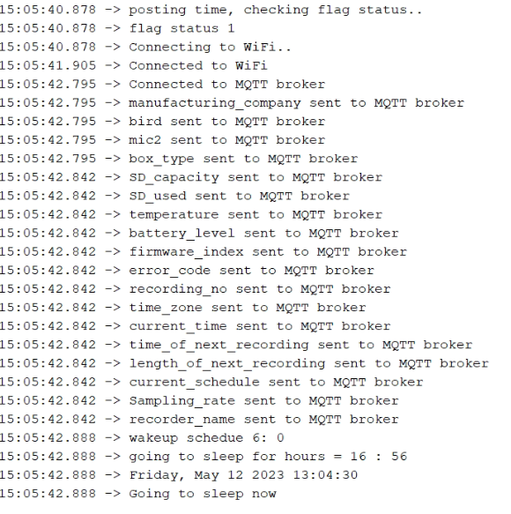

* Currently the device restarts after wakeup from sleep. Due to which we are unable to handle the case when the ESP32 restarts between sleep schedules due to any reason of power down.

# Tasks for next week

* Resolve the multiple posting issues if the ESP restarts between deep sleep.
* Use NB-IOT SIM card with SIM7000G module to connect to internet.
* Test the device for multiple days.